Project Design Phase-II
Smart Sorting : Transfer Learning For Identifying
Rotten Fruits and Vegetables
(Technology Stack (Architecture & Stack))

Date | 28 February 2026
Team ID | LTVIP2026TMIDS87250
Project Name | Smart sorting: transfer Learning For Identifying Rotten Fruits and Vegetables
Maximum Marks | 4 Marks

Technical Architecture:
The Deliverable shall include the architectural diagram as below and the information as per the table1 & table 2
Architecture Description:
A web-based intelligent classification system that allows users to upload images of fruits/vegetables, which are processed through a pretrained transfer learning model (e.g., MobileNet, VGG16) to classify them as fresh or rotten. Results are displayed via a UI, with admin controls for dataset management and retraining.
Architecture Includes:
- User interacts via web UI
- Frontend sends image to backend via Flask API
- Backend processes image using CNN transfer learning model
- Classification result is returned and displayed
- Admin manages datasets and retrains models
- All data (images, logs, feedback) is stored locally/cloud

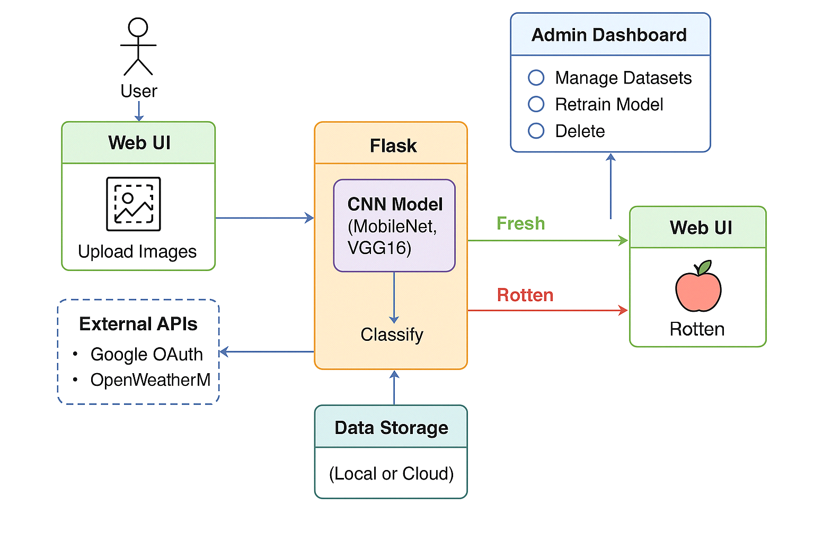

Table-1 : Components & Technologies:
S.No | Component | Description | Technology
 | User Interface | Interface for image upload, result viewing, and admin panel | HTML, CSS, JavaScript, Bootstrap
 | Application Logic-1 | Image upload and preprocessing logic | Python + Flask
 | Application Logic-2 | Image classification using ML model | Transfer Learning (MobileNet / VGG16)
 | Application Logic-3 | Dataset feedback and retraining module | Python, TensorFlow / Keras
 | Database | Storage of prediction results and feedback | SQLite / MySQL
 | File Storage | Storage for image uploads and training data | Local Filesystem / AWS S3
 | Machine Learning Model | Transfer learning for fruit/vegetable classification | CNN (MobileNet / ResNet / VGG16, etc.)
 | Infrastructure | Model runs on local server; scalable to cloud deployment | Localhost / Flask Server / Google Colab / AWS EC2.

Table-2: Application Characteristics:
S.No | Characteristics | Description | Technology
 | Open-Source Frameworks | Deep learning, backend, frontend frameworks | TensorFlow, Flask, Bootstrap, React (opt.)
 | Security Implementations | Authentication, data access control | OAuth 2.0, HTTPS, SHA-256
 | Scalable Architecture | Can shift from single-tier to 3-tier or cloud-microservice-based system | Flask APIs, AWS EC2, Docker (optional)
 | Availability | Can host via cloud servers with failover | AWS / GCP / Heroku
 | Performance | Optimized image preprocessing, batching, and model caching | TensorFlow Lite (optional), Flask Caching

